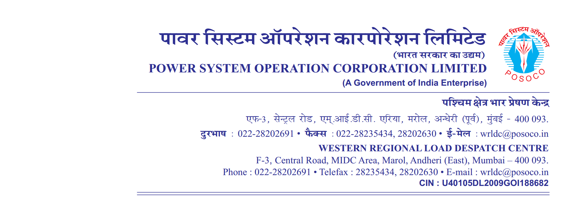

**साप्ताहिक विवरण**

Weekly Report **वर्ष** / सप्ताह संख्या **अवधि**  **से**

Year / Week No Period from to

1. (**आवृति रूपरेखा**) Frequency Profile

|  |  |  |  |  |  |  |  |  |  |  |
| --- | --- | --- | --- | --- | --- | --- | --- | --- | --- | --- |
| **दिनांक** | **अधिकतम तात्कालिक** | **न्युनतम तात्कालिक** | **औसत** | **% of time 49.9**  **से कम** | **% of time 49.9 से 50.05 तक** | **% of time 50.05 से उपर** | **Percentage of Time Frequency Remained outside IEGC Band** | **No’s of hours frequency remained outside IEGC Band** | **FDI =No. of hours out of IEGC band/24Hrs** | **Weekly FDI =No. of hours out of IEGC band/24*7Hrs** |
| **Date** | **Maximum Inst.** | **Minimum Inst.** | **Average** | **<49.9** | **49.9 – 50.05** | **>50.05** | **(Hours)** |
|  | **(Hz)** | **(Hz)** | **(Hz)** | **(%)** | **(%)** | **(%)** | **(%)** |  |
|  |  |  |  |  |  |  |  |  |  |  |
|  |  |  |  |  |  |  |  |  |  |
|  |  |  |  |  |  |  |  |  |  |
|  |  |  |  |  |  |  |  |  |  |
|  |  |  |  |  |  |  |  |  |  |
|  |  |  |  |  |  |  |  |  |  |
|  |  |  |  |  |  |  |  |  |  |